BA – Tableau - Assignment 2

**QUIZ:-**

1. What is the total sales of the store?

Ans: 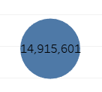

1. What is the total sales of product category = “Furniture”?

Ans: 5,178,791

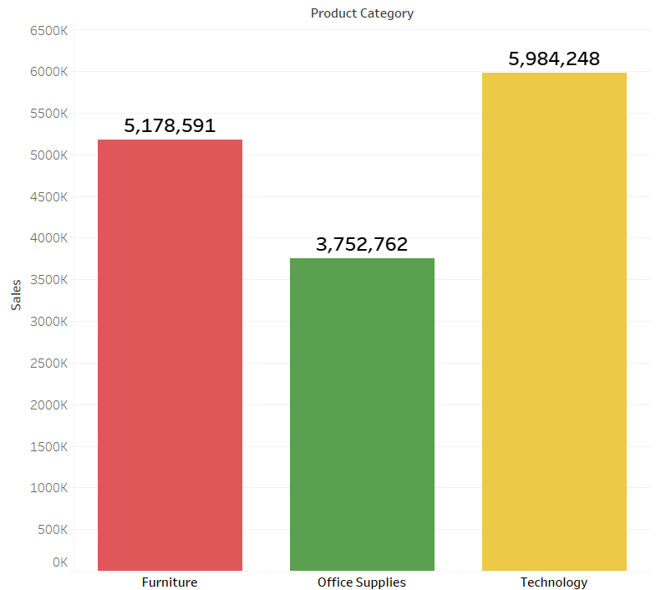

1. What is the total sales of product category = “Furniture” sold to Customer

Segment = “Corporate”?

Ans: 1,862,841

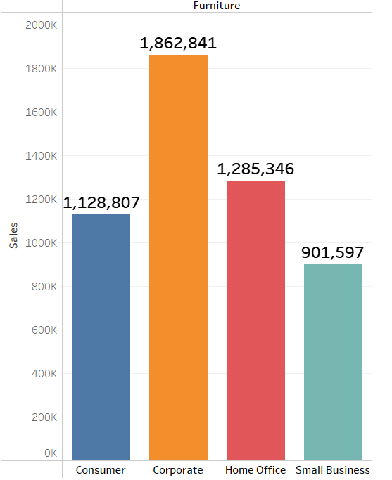

1. Set the number format of Discount to percentage with 2 decimal places.  
   Ans: 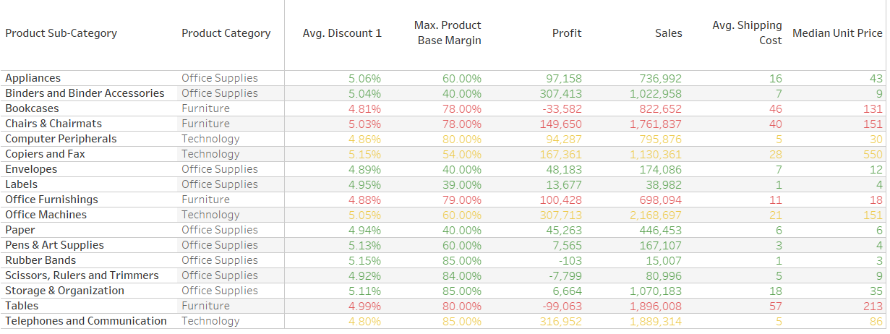
2. Find average discount on each order priority. Which order priority has the highest average discount? Ans: 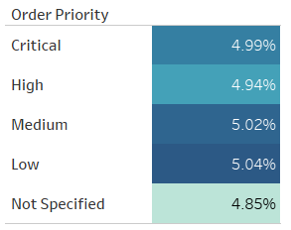
3. For Product Container = “Large Box” which Ship Mode has lowest average shipping cost?

Ans: 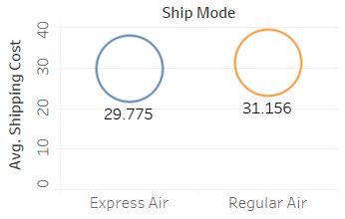Express Air

1. For Product Container = “Medium Box” which Ship Mode has lowest average shipping cost?

Ans: 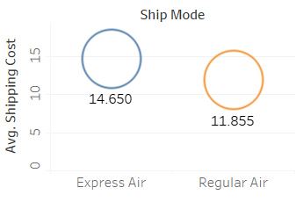 Regular Air

1. Which Ship Mode uses only “Jumbo” sized Product Containers?

Ans: 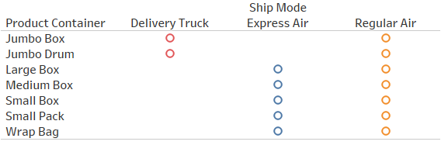 Delivery Truck

1. Which Ship Mode doesn’t entertain “Jumbo” sized Product Containers?

Ans: Express Air